模块XD03弹窗
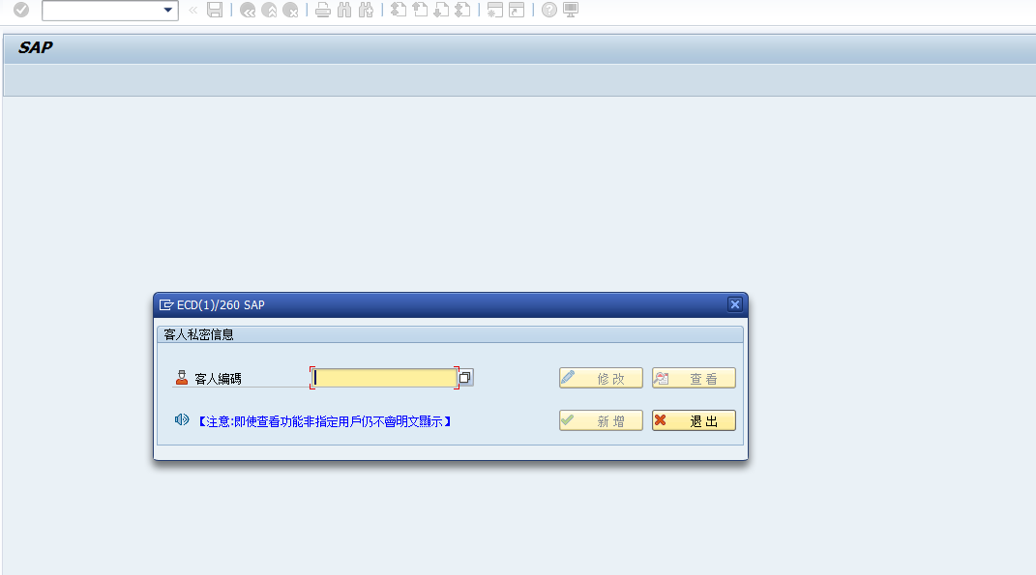
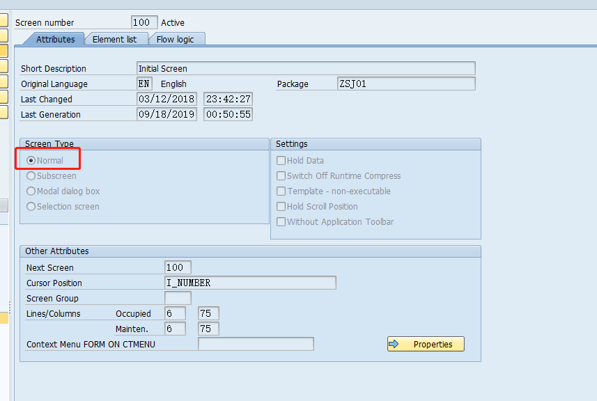
PROCESS BEFORE OUTPUT.
MODULE STATUS_0100.
PROCESS AFTER INPUT.
MODULE USER_COMMAND_0100.
*&---------------------------------------------------------------------*
*& Module STATUS_0100 OUTPUT
*&---------------------------------------------------------------------*
MODULE STATUS_0100 OUTPUT.
SET PF-STATUS 'STATUS_0100'.
"檢查權限
C_ADD = ''.C_UPDATE = ''.C_SEARCH = ''.
SELECT * INTO CORRESPONDING FIELDS OF TABLE IT_ZFI27 FROM ZTFI027 WHERE USERS = SY-UNAME.
READ TABLE IT_ZFI27 WITH KEY ACODE = 'ADD'.
IF SY-SUBRC = 0. C_ADD = 'X'. ENDIF.
READ TABLE IT_ZFI27 WITH KEY ACODE = 'UPDATE'.
IF SY-SUBRC = 0. C_UPDATE = 'X'. ENDIF.
READ TABLE IT_ZFI27 WITH KEY ACODE = 'SEARCH'.
IF SY-SUBRC = 0. C_SEARCH = 'X'. ENDIF.
LOOP AT SCREEN.
IF SCREEN-NAME = 'BTN_ADD' AND C_ADD = ''..
SCREEN-INPUT = '0'.
MODIFY SCREEN.
ENDIF.
IF SCREEN-NAME = 'BTN_UPDATE' AND C_UPDATE = ''.
SCREEN-INPUT = '0'.
MODIFY SCREEN.
ENDIF.
IF SCREEN-NAME = 'BTN_SEARCH' AND C_SEARCH = ''.
SCREEN-INPUT = '0'.
MODIFY SCREEN.
ENDIF.
ENDLOOP.
ENDMODULE.
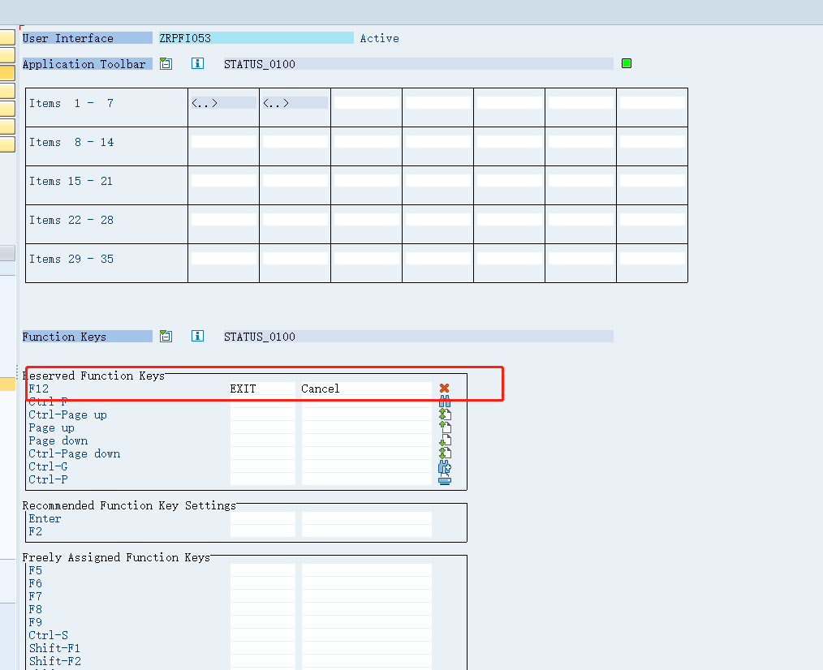
*&---------------------------------------------------------------------*
*& Module USER_COMMAND_0100 INPUT
*&---------------------------------------------------------------------*
MODULE USER_COMMAND_0100 INPUT.
"判斷事件對象
CASE SY-UCOMM.
WHEN 'EXIT'.
LEAVE PROGRAM.
WHEN 'ADD'.
IF I_NUMBER <> ''.
CALL FUNCTION 'CONVERSION_EXIT_ALPHA_INPUT'
EXPORTING
INPUT = I_NUMBER
IMPORTING
OUTPUT = I_NUMBER.
SELECT * INTO CORRESPONDING FIELDS OF TABLE IT_KNA1 FROM KNA1 WHERE KUNNR = I_NUMBER.
IF LINES( IT_KNA1 ) > 0.
READ TABLE IT_KNA1 INDEX 1.
IF SY-SUBRC = 0.
"客人信息
I_KUNNR = IT_KNA1-KUNNR.
I_NAME1 = IT_KNA1-NAME1.
ENDIF.
ENDIF.
"新增轉賬類型
CALL SCREEN 0200 STARTING AT 25 20 ENDING AT 60 26.
ELSE.
STR_MESSAGE = '必填信息:客人編碼不能為空.'.
MESSAGE STR_MESSAGE TYPE 'I' DISPLAY LIKE 'E'.
ENDIF.
WHEN 'UPDATE'.
PERFORM FRM_0100_MANIN_FORM.
WHEN 'SEARCH'.
PERFORM FRM_0100_MANIN_FORM.
ENDCASE.
CLEAR SY-UCOMM.
ENDMODULE.
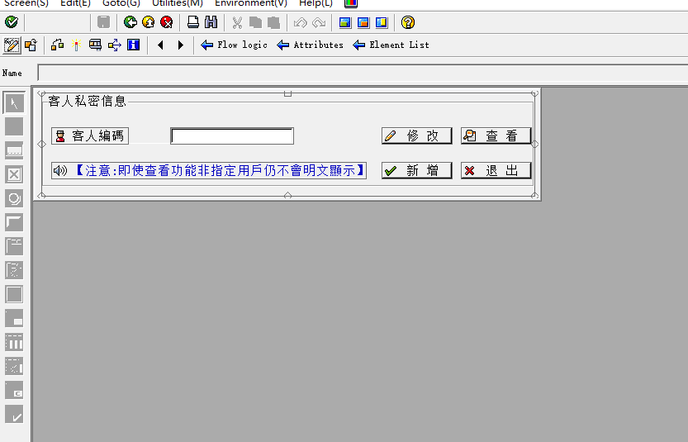
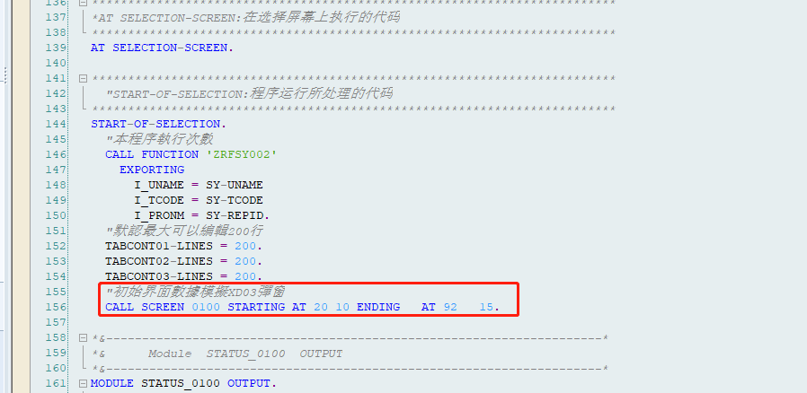
"初始界面數據模擬XD03彈窗
CALL SCREEN 0100 STARTING AT 20 10 ENDING AT 92 15.

